Exercise 5: LiDAR Data Analysis and 3D Visualization
This exercise describes how to work with light detection and ranging (LiDAR) data in ArcGIS Pro. LiDAR data are commonly made available as point clouds in LAS format. You will learn to process these LiDAR data to create LiDAR dataset, digital elevation models (DEMs), digital surface models (DSMs), normalized digital surface models (nDSMs), first return intensity images, and hillshades. You will also explore the statistics of the point cloud and 3D Visualization using point cloud.
Topics covered in this exercise include:
- Create LiDAR dataset
- Filter point clouds
- Rasterize LiDAR point cloud data as DEMs, DSMs, nDSMs, and intensity images.
- Analyze and interpret LiDAR derivatives
- Explore point cloud statistics
- 3D visualization

Data
This project contains one LiDAR data: USGS_LPC_AK_Fairbanks_NSB_Lidar_2017_B17_FB17_4186.las, collected in the city of Fairbanks, and its surrounding area in Alaska, US. The data was downloaded from the USGS LiDAR Explorer. Download Exercise_5.zip. Save it in the location you are choosing and unzip it by right-clicking on Exercise_5.zip. In the drop-down window, choose “Extract All”.

Step 1. Create a Project in ArcGIS Pro

- In the search bar at the left corner, type “ArcGIS Pro”. You will see the software “ArcGIS Pro”. Click on it, the ArcGIS Pro will be loaded.
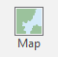
Note, this can also be done by navigating to All Apps followed by the ArcGIS Folder. Within the ArcGIS Folder, select ArcGIS Pro.
- Create a project to host your maps by clicking on the Map icon.
- The Create a New Project window should be shown. Define the name for your project. You can give any name that you prefer. Then click on Folder icon, find the location where you want to save your project.
- You do not need to change others.
- Click on OK.

Step 2. Create a LAS Dataset
In order to work with LiDAR data in ArcGIS Pro, you must create a LAS Dataset from the LAS files. This can be accomplished using the Create LAS Dataset Tool.
- Navigate to Data Management Tools followed by the LAS Dataset subtoolbox. Click on the Create LAS Dataset Tool.
- Add the LAS file from the Exercise_5 folder to the Input Files list (i.e., USGS_LPC_AK_Fairbanks_NSB_Lidar_2017_B17_FB17_4186.las).
- Name the Output LAS Dataset Fairbanks_lidar_data.lasd and save it to a location of your choosing.
- You do not need to change any of the other settings.
- Click Run to execute the tool.
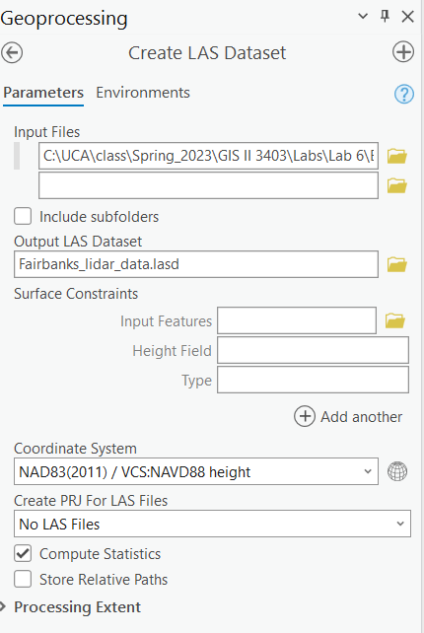

The Fairbanks_lidar_data.lasd layer should be automatically added to the Contents pane. When you are zoomed out, the extent of the LiDAR tiles are drawn as red boxes. If you want to see individual points, you will need to zoom in.

Question 1. What is the linear unit of projected and vertical coordinate systems of the LiDAR dataset? (3 Points) (Hint, right-click on Fairbanks_lidar_data.lasd layer, in the drop-down menu, select Properties, followed by Source and Spatial Reference)
Projected: US Feet; Vertical: US Feet

Step 3. Create a DEM
You will now convert the point cloud data to a digital elevation model or DEM. To create this surface, you only want to use ground returns. So, you will first need to adjust the filter.
- Right-click on the Fairbanks_lidar_data.lasd layer in the Contents Pane then select LAS Filter followed by Ground.
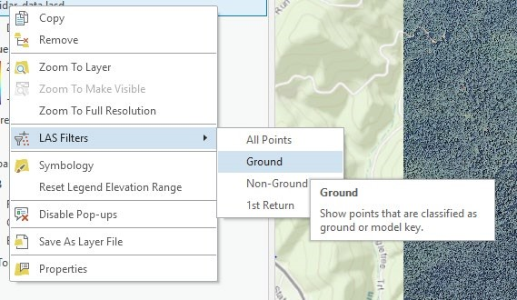

Question 2. Are there any changes in the LiDAR cloud point map? (3 Points)
Yes, only point on the ground show there

Now, only ground returns should be displayed or used in an analysis. You are now ready to create the DEM.
- Navigate to Conversion Tools followed by the Point Cloud subtoolbox.
- Click on the LAS Dataset to Raster Tool.
- Set the Input LAS Dataset to the Fairbanks_lidar_data.lasd layer.
- Name the Output Raster dem and save it to a location of your choosing.
- Make sure the Value Field is set to Elevation.
- Make sure the Interpolation Type is set to Binning, the Cell Assignment is Average, and the Void Fill Method is Linear.
- Make sure the Output Data Type is set to Floating Point.
- Make sure the Sampling Type is set to Cell Size.
- Set the Sampling Value to 5.
- Click Run to execute the tool.
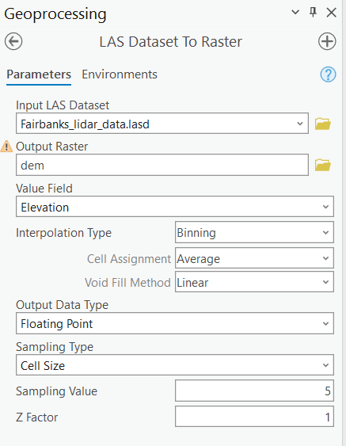

Step 4. Create a Hillshade
To visualize the terrain, you will now create a hillshade from the DEM.
Recap
- Navigate to Spatial Analyst Tools followed by the Surface subtoolbox. Click on the Hillshade Tool.
- Set the Input Raster to the dem layer.
- Name the Output Raster hs and save it to a location of your choosing.
- You do not need to change any of the other settings.
- Click Run to execute the tool.

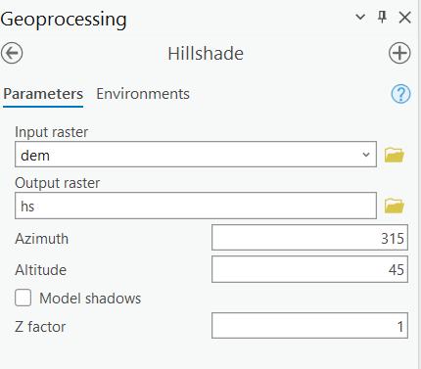

Question 3. Compare the dem map, what did you find in the hs map (3 Points) (Hint, you will need to turn on/off dem and hs maps to see the difference)
Building, road

Step 5. Create a DSM
You will now need to create a surface that includes not just ground elevations but also incorporates aboveground features, such as buildings and trees. This is called a digital surface model or DSM. You will create this surface from the first laser pulse returned, so you will need to change the filter.
- Right-click on the Fairbanks_lidar_data.lasd layer in the Contents Pane, then select Properties. Navigate to LAS Filter. This is another way to filter the points cloud.
- Under Return Values make sure only 1 is selected. Note, the first returns are the first objects encountered. In a forested setting, these would be the topmost branches of trees.
- You do not need to change others.
- Click Apply followed by OK to change the filter.

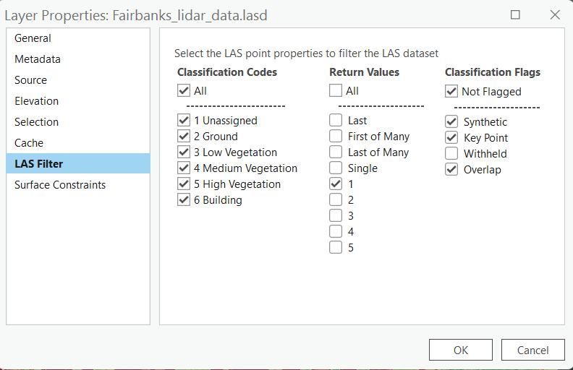

You are now ready to create the DSM using the LAS Dataset to Raster Tool.
- Navigate to Conversion Tools followed by the Point Cloud subtoolbox.
- Click on the LAS Dataset to Raster Tool.
- Set the Input LAS Dataset to the Fairbanks_lidar_data.lasd layer.
- Name the Output Raster dsm and save it to a location of your choosing.
- Make sure the Value Field is set to Elevation.
- Make sure the Interpolation Type is set to Binning, the Cell Assignment is Maximum, and the Void Fill Method is Linear. Note, we choose Maximum, rather than Average, as we will pick the highest return points for the tree or buildings.
- Make sure the Output Data Type is set to Floating Point.
- Make sure the Sampling Type is set to Cell Size.
- Set the Sampling Value to 5.
- Under Environments, set the Snap Raster to the dem layer. This will make the two layers align correctly.
- Click Run to execute the tool.

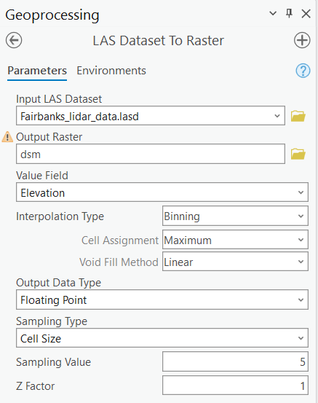

Step 6. Create an nDSM from the DEM and DSM
A normalized digital surface model (nDSM) is a DSM that has had the ground elevations subtracted out. So, it can be created by subtracting the DEM from the DSM. This surface represents the height of above-ground features, such as trees and buildings. You will now create this surface using the Raster Calculator Tool.
- Navigate to Spatial Analyst Tools followed by the Map Algebra subtoolbox. Click on the Raster Calculator Tool.
- Use the following syntax: "dsm" - "dem".
- Name the Output Raster ndsm and save it to a location of your choosing.
- Under Environments, set the Snap Raster to the dem layer. This will make the two layers align correctly.
- Click Run to execute the tool.
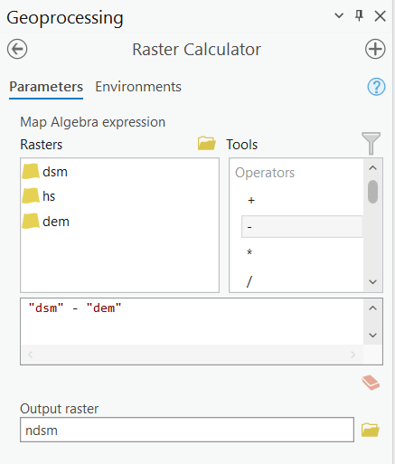
To better understand the ndsm layer, change the symbology for the layer.
- Right-clicking on ndsm layer, in the drop-down menu, select Symbology.
- In the Symbology window, change the Color scheme you prefer.
To refer to the true background information, change the Basemap to Imagery.
- Navigate to Map Tab, click on Basemap, in the drop-down menu, select Imagery.
Turn off dsm, hs, and dem layers.

Deliverable 1. Screenshot your ndsm map. (5 Points)

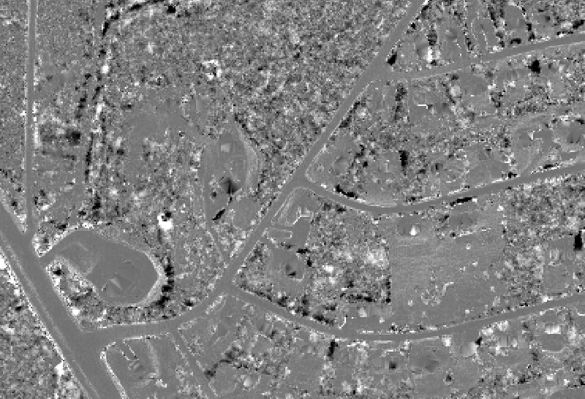

Question 4. Using the aerial image and the nDSM, what features on the landscape in this area are producing above-ground heights? (3 Points)
Trees,

Step 7. First Return Intensity Image
Other than producing DEMs and DSMs, it is also possible to create return intensity images from the point cloud data. Different surfaces will absorb more or less of the infrared laser energy. Thus, these images are correlated with land cover.
Note: The DSM was created from the first returns. This is the same filter that is required to create the first return intensity image. So, you will not need to filter the data again.
- Navigate to Conversion Tools followed by the Point Cloud subtoolbox.
- Click on the LAS Dataset to Raster Tool.
- Set the Input LAS Dataset to the Fairbanks_lidar_data.lasd layer.
- Name the Output Raster frst_int and save it to a location of your choosing.
- Make sure the Value Field is set to Intensity.
- Make sure the Interpolation Type is set to Binning, the Cell Assignment is Average, and change the Void Fill Method to None.
- Make sure the Output Data Type is set to Floating Point.
- Make sure the Sampling Type is set to Cell Size.
- Set the Sampling Value to 5.
- Click Run to execute the tool.

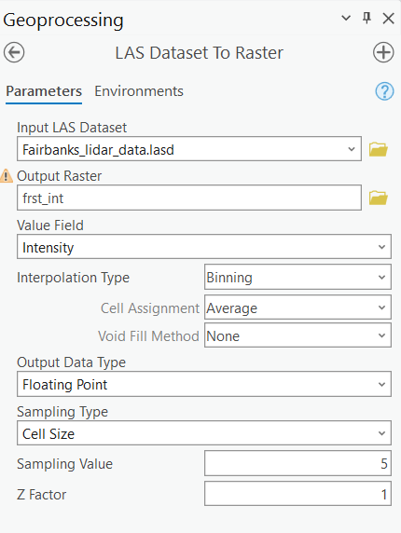

We did not have you fill the voids because we assumed that cells that did not contain a return may have absorbed all of the infrared energy. We would now like you to code these cells as 0. This can be accomplished using a conditional statement in the Raster Calculator Tool.
- Navigate to Spatial Analyst Tools followed by the Map Algebra subtoolbox. Click on the Raster Calculator Tool.
- Use the following syntax: Con(IsNull("frst_int"), 0, "frst_int").
- Name the Output Raster frst_int2 and save it to a location of your choosing.
- Click Run to execute the tool.
Note: Here is an interpretation of the syntax. If the cell holds the null assignment, change the value to 0. If it does not hold the null assignment, or hold any other value, return the original value. So, this syntax replaces null or NoData values with 0 and does not impact any other cells.

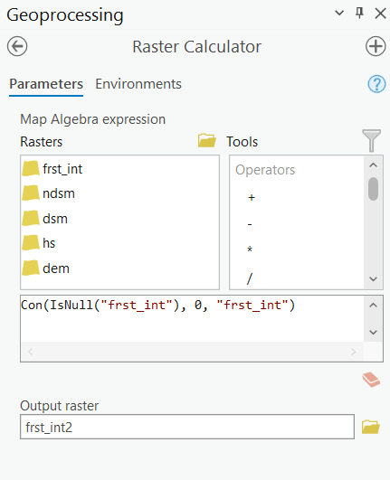

To better understand the intensity layer, change the symbology for the layer.
- Right-clicking on frst_int2 layer, in the drop-down menu, select Symbology.
- In the Symbology window, change the Color scheme you prefer.
In the Symbology window, change the Color scheme you prefer.
Use the intensity image and aerial image to answer the following questions.

Deliverable 2. Screenshot your frst_int2 map. (5 Points)
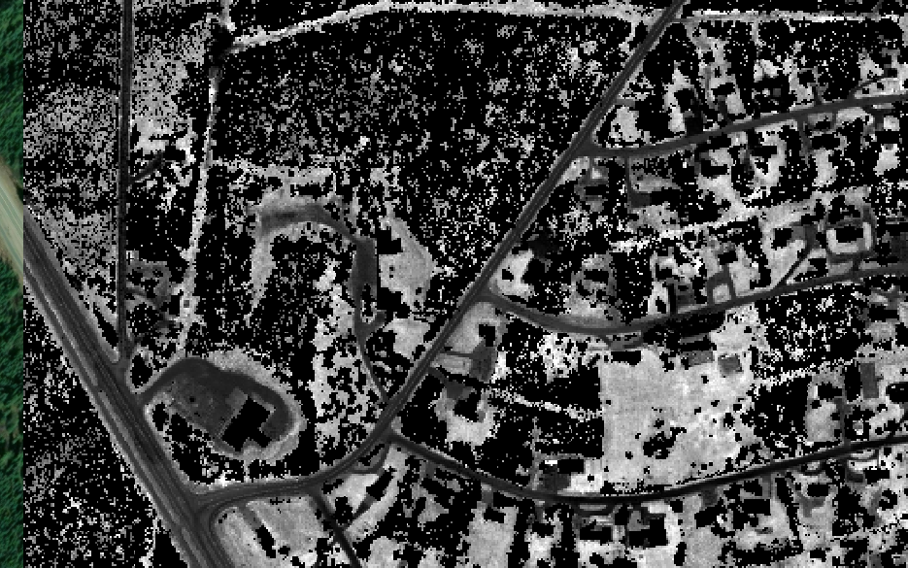

Question 5. Do grasslands generally show low or high first return intensity? (3 Points)
high

Question 6. Do the roofs of the house generally show low or high return intensity? (3 Points)
low

Question 7. Compared to grasslands and roofs, do the forests generally show low or high return intensity? (3 Points)
Kind of low, and some are medium

Step 8. Obtaining Point Statistics
It is possible to calculate statistics for the LiDAR point cloud using the LAS Dataset Statistics Tool. You will now run this tool on your dataset.
- Right-click on the Fairbanks_lidar_data.lasd layer in the Contents Pane then select LAS Filter followed by All points.
- Navigate to Data Management Tools followed by the LAS Dataset subtoolbox. Click on the LAS Dataset Statistics Tool.
- Set the Input LAS Dataset to the Fairbanks_lidar_data.lasd layer.
- Name the Output Statistics Report Text File lidar_report.txt and save it to a location of your choosing. Make sure to include the file extension.
- Make sure the Summary Level is set to Aggregate Statistics for All Files.
- Make sure the Decimal Separator is set to Point.
- Make sure the Delimiter is set to Comma.
- Click Run to execute the tool.
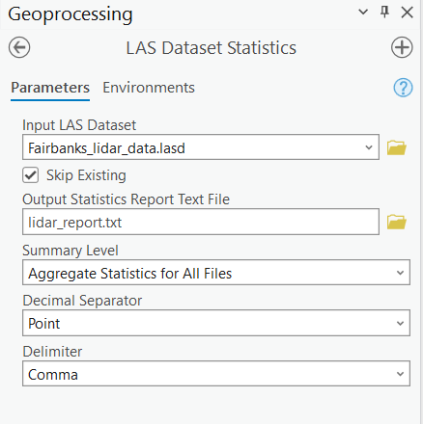
The tool will generate a text file that is added to the Contents Pane. Open this table and use it to answer the following questions.

Question 8. What percentage of the returns were first returns? (3 Points) (Hint, the value is under Percent field)
67.09

Question 9. What percentage of the returns were classified as ground returns? (3 Points)
6.89

Step 9. Obtaining LAS Point Statistics as a Raster Grid
It is also possible to obtain statistics relating to the laser scanning data within a grid cell using the LAS Point Statistics As Raster Tool. Here, you will calculate the most frequent class code within 10 by 10 meters cells.
- Navigate to Data Management Tools followed by the LAS Dataset subtoolbox. Click on the LAS Point Statistics As Raster Tool.
- Set the Input LAS Dataset to the Fairbanks_lidar_data.lasd layer.
- Name the Output Raster common_class and save it to a location of your choosing.
- Set the Method to Most Frequent Class Code.
- Set the Sampling Type to Cell Size and the Sampling Value to 30. This will produce a grid with a ~ 10 by 10 meter cell size.
- Click Run to execute the tool.

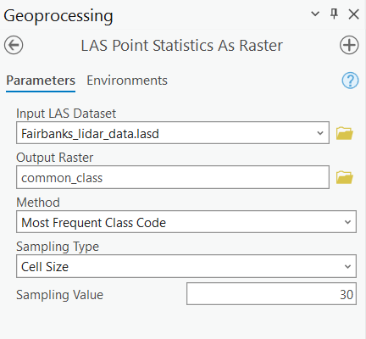

To better understand the layer, change the symbology for the layer.
- Right-clicking on common_class layer, in the drop-down menu, select Symbology.
- In the Symbology window, set Primary symbology as “Unique Values”, change the Color scheme you prefer.
A code of 1 indicates unassigned, 2 for ground, 3 for low vegetation, 4 for medium vegetation, 5 for high vegetation, and 6 for building. Use this information, the common_class layer, and the aerial image to answer the following questions.

Deliverable 3. Screenshot your common_class map. (5 Points)
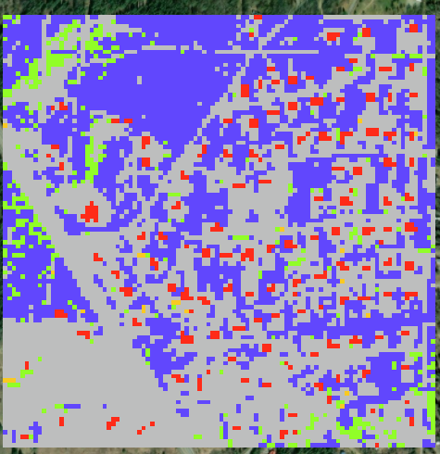

Question 10. Did the building shown in common_class layer align with that in aerial image? (3 Points)
yes

Step 10. 3D Visualization
Now, you will generate a 3D map using the local scene in ArcGIS Pro.
- Navigate to Insert Tab. Click on New Map, in the drop-down menu, select New Local Scene.
- Navigate to Map Tab. Click on Add Data.
- Add the LAS file from the Exercise_6 folder to the Input Files list (i.e., USGS_LPC_AK_Fairbanks_NSB_Lidar_2017_B17_FB17_4186.las).
Wait for a while, the cloud points will be added. Note, due to the large dataset, ArcGIS Pro may be crushed. Please save your project frequently.
- Right-click on the USGS_LPC_AK_Fairbanks_NSB_Lidar_2017_B17_FB17_4186.las layer in the Contents Pane then select Properties. Navigate to LAS Filter.
- Under Classification Codes, make sure only Low Vegetation is checked.
- Click on Apply followed by OK.
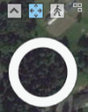
You can zoom into different places to see the 3D map. You can also click on the navigation panel on the lower left place to view the map from different perspectives.
Play with different filters to see the difference.

Deliverable 4. Screenshot your 3D map for buildings. (5 Points) (Hint, you need to make sure only building is checked under Classification Codes)
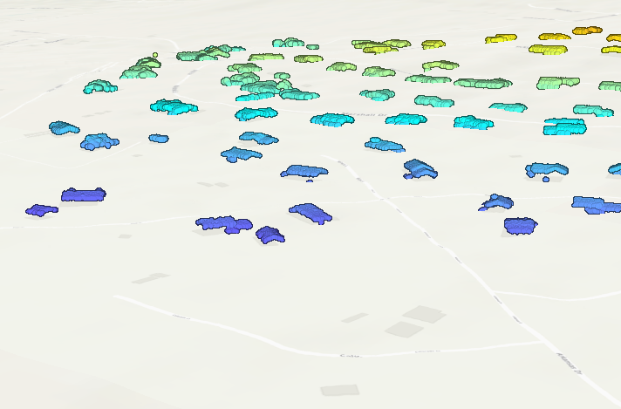

END OF EXERCISE

Homework
Please submit a word file with 10 questions and 4 deliverables. Please submit through Blackboard.

